SQL Lab Questions
Dataset: CompanyDB
Table 1: Employees
emp_id | emp_name | dept_id | salary | hire_date | city
101 | Anuj | 1 | 50000 | 2022-01-10 | Delhi
102 | Ravi | 2 | 60000 | 2021-03-15 | Mumbai
103 | Neha | 1 | 55000 | 2020-07-20 | Delhi
104 | Amit | 3 | 70000 | 2019-11-01 | Pune
105 | Sneha | 2 | 65000 | 2023-05-12 | Mumbai
106 | Karan | 3 | 72000 | 2018-08-25 | Bangalore
107 | Pooja | 1 | 48000 | 2022-09-30 | Delhi
108 | Raj | 2 | 52000 | 2021-12-11 | Chennai
109 | Meena | 3 | 68000 | 2020-02-14 | Pune
110 | Vikas | 1 | 51000 | 2023-01-18 | Delhi

Table 2: Departments
dept_id | dept_name
1 | HR
2 | Sales
3 | IT

Table 3: Projects
project_id | project_name | dept_id | budget
201 | Alpha | 1 | 100000
202 | Beta | 2 | 150000
203 | Gamma | 3 | 200000
204 | Delta | 2 | 120000

Table 4: Attendance
emp_id | date | status
101 | 2024-03-01 | Present
102 | 2024-03-01 | Absent
103 | 2024-03-01 | Present
104 | 2024-03-01 | Present
105 | 2024-03-01 | Absent
106 | 2024-03-01 | Present
107 | 2024-03-01 | Present
108 | 2024-03-01 | Present
109 | 2024-03-01 | Absent
110 | 2024-03-01 | Present

SQL Questions (Lab Practice)
Basic Level (1–10)
- Retrieve all employees.
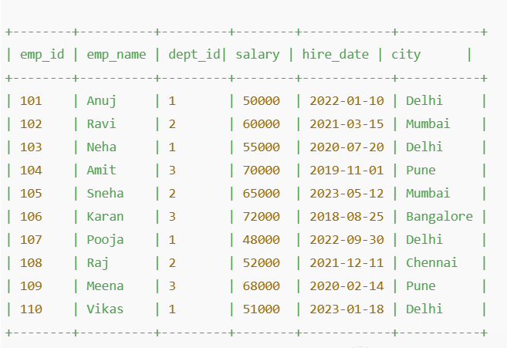
- Display only emp_name and salary.
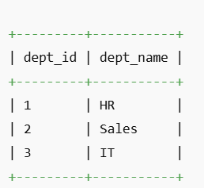
- Find employees working in department 1.
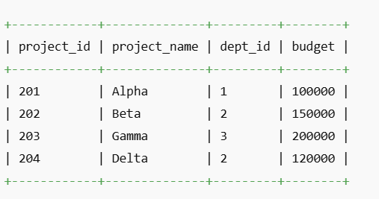
- List employees from Delhi.
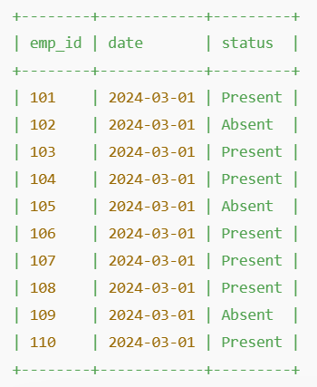
- Show employees with salary greater than 60000.
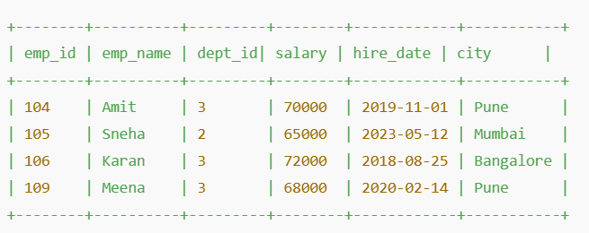
- Find employees hired after 2021.
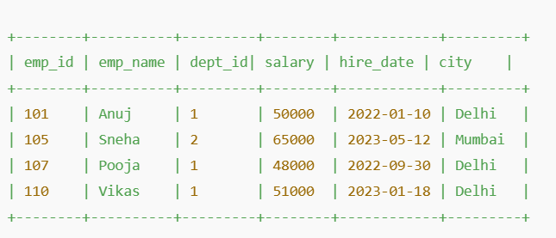
- Display unique cities.
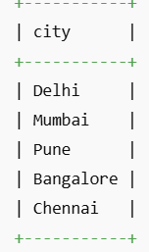

- Sort employees by salary (descending).
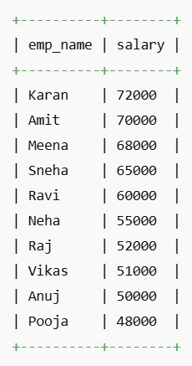
- Count total employees.
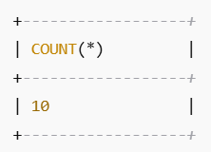
- Find average salary.
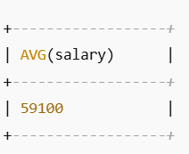

Intermediate Level (11–20)
- Find total salary paid per department.
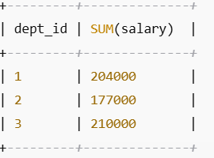

- Count employees in each department.
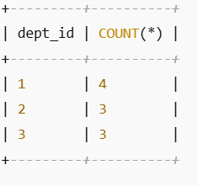
- Find highest salary in each department.
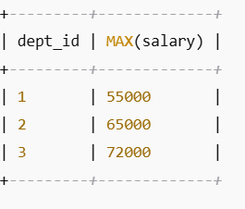
- Display employees along with department names.
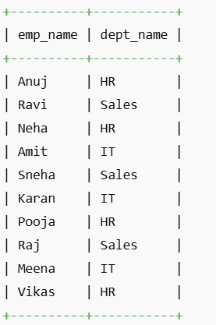
- List employees working on Sales department.
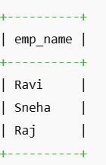
- Find employees whose name starts with 'A'.
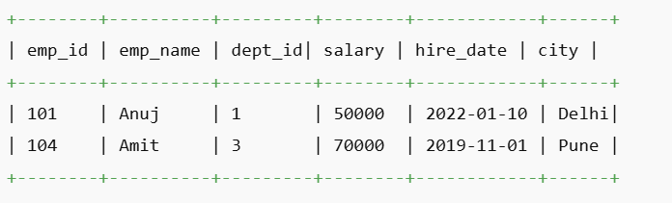
- Get employees with salary between 50000 and 70000.
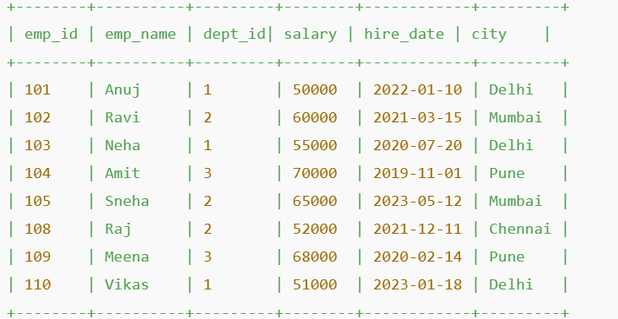
- Find employees not from Mumbai.
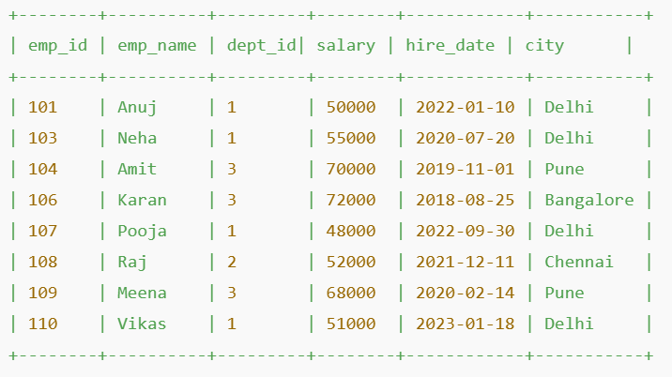
- Show employees hired in 2022.
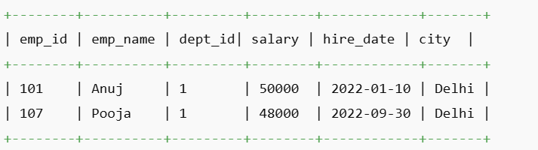
- Find top 3 highest paid employees.
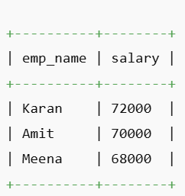

Joins (21–25)
- INNER JOIN Employees and Departments.
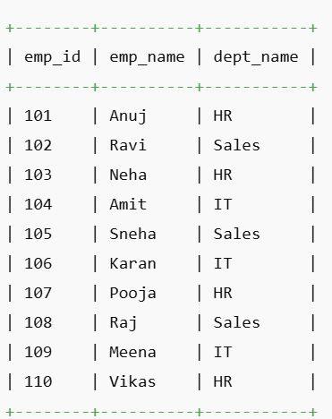
- LEFT JOIN to show all employees with department names.
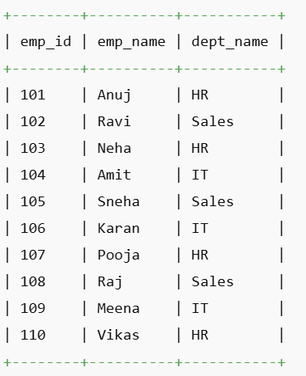
- Find employees working in IT department.
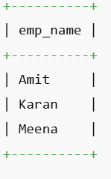
- Show project names with department names.
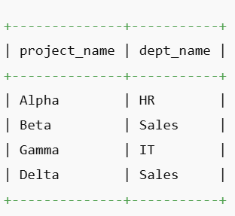
- Find employees and their project budgets (via department).
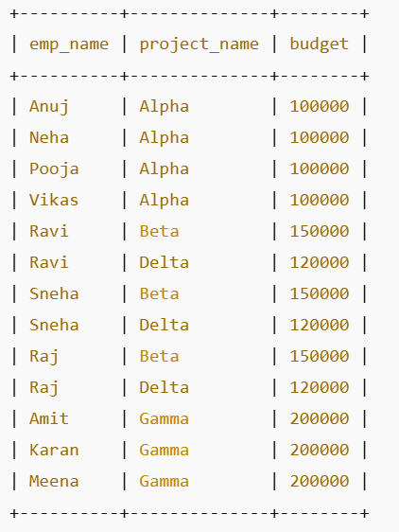

Advanced Level (26–30)
- Find second highest salary.
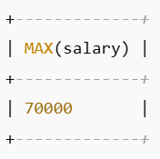
- Rank employees by salary.
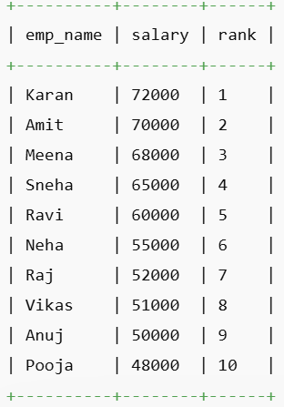
- Find employees earning above average salary.
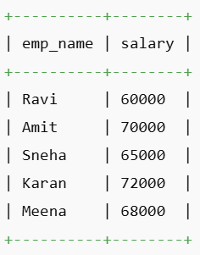
- Get department with highest total salary.
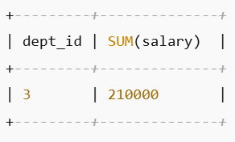
- Find employees who were absent on 2024-03-01.
